**Mini Project Synopsis**



● NAME OF THE GUIDE: - **Dr.Avantika Mahadik**

|  |
| --- |
| **1. Mini Project Topic/Title:** |
| **User Management System.** |

1. **Details of Member:**

|  |  |  |  |  |  |
| --- | --- | --- | --- | --- | --- |
| **Roll No.** | **Class** | **Division** | **Name of Student** | **Mobile Number** | **Email Id** |
| MCA2023044 | FYMCA | A | Rohit Phatangare | 9309109943 | rohitvrp23@gmail.com |

1. **Project Overview / Background:**

**Introduction:**

Welcome to our User Management System powered by Node.js! Our system is designed to streamline the process of managing users within your application or organization. With a robust stack leveraging the power of Node.js, along with other complementary technologies, we offer a comprehensive solution for user authentication, authorization, and administration.

In today's digital landscape, effective user management is paramount for ensuring security, maintaining data integrity, and delivering personalized experiences. Our system provides a seamless experience for administrators to efficiently manage user accounts, permissions, and access controls, while also empowering users with intuitive interfaces for registration, login, and profile management.

Whether you're running a small-scale application or managing a large enterprise system, our User Management System provides the tools and functionality you need to effectively manage users and drive user-centric experiences.

Thank you for choosing our User Management System. We're excited to partner with you on your journey towards seamless user management!

1. **Need of Work / Reason for selection of this project:**

* **Streamlining User Management:** In today's digital age, managing user accounts efficiently is crucial for any application or organization. This project was chosen to streamline user management processes, making it easier for administrators to handle tasks such as account creation, modification, and deactivation.
* **Enhanced Security Measures**: With the increasing number of cyber threats, implementing robust security measures is imperative. This project provides features such as secure authentication and authorization, helping to protect sensitive user data and prevent unauthorized access.
* **Scalability and Performance**: As our organization grows, so does the demand for scalable and high-performing systems. This project, built on Node.js, offers scalability and performance optimizations, ensuring that the user management system can handle increasing user loads without compromising on speed or reliability.
* **Customization and Adaptability**: Every organization has unique requirements when it comes to user management. This project was selected for its flexibility and customization options, allowing us to tailor the system to our specific needs and integrate it seamlessly with existing workflows and technologies.

1. **Objective:**
2. **Secure Authentication**: Implementing industry-standard authentication mechanisms, we ensure the integrity of user credentials and safeguard against unauthorized access.
3. **Flexible User Roles and Permissions**: Administrators can define custom roles and permissions tailored to the specific needs of their application, allowing for granular control over user access to resources and functionalities.
4. **User Profile Management**: Users have the ability to manage their profiles, update personal information, and adjust preferences, enhancing their overall experience and engagement.
5. **Efficient User Administration**: Administrators can easily add, modify, or deactivate user accounts, as well as perform bulk operations when necessary, streamlining administrative tasks and reducing overhead.
6. **Scalability and Performance**: Built on Node.js, our system is designed to be highly scalable and performant, capable of handling large volumes of user data and concurrent requests with ease.
7. **Customizable and Extendable**: Our system is built with modularity and extensibility in mind, allowing for easy customization and integration with other components or third-party services as needed.

**6 Problem Statement:**

In today's digital landscape, the management of user data within applications and organizations poses significant challenges. As businesses expand and digital interactions proliferate, the need for a robust and efficient User Management System becomes paramount. The absence of such a system can lead to security vulnerabilities, data inconsistencies, and operational inefficiencies.

**Problem Description**:

* **Inefficient User Data Handling**: Without a centralized system in place, user data is often scattered across multiple databases or platforms, leading to redundancies and inconsistencies. This makes it difficult to maintain data integrity and perform accurate analytics.
* **Security Concerns**: Storing sensitive user information without proper encryption or access controls exposes organizations to security breaches and compliance risks. Unauthorized access to user data can result in financial losses, legal liabilities, and damage to reputation.
* **Manual Administrative Tasks**: The lack of automation in user management processes leads to an over-reliance on manual interventions. Administrators are burdened with repetitive tasks such as user registration, account updates, and access control, which are prone to errors and delays..

1. **Benefits to the surrounding/society:**

* **Enhanced Data Security**: By implementing robust authentication mechanisms and access controls, the User Management System helps protect user data from unauthorized access and breaches. This contributes to a safer digital environment, reducing the risk of identity theft, fraud, and privacy violations within the community.
* **Improved Efficiency and Productivity**: Streamlining administrative tasks such as user registration, account management, and access control leads to greater efficiency and productivity for businesses and organizations. By automating repetitive processes, the system frees up valuable resources and enables staff to focus on more strategic initiatives, thereby fostering economic growth and innovation within the community.
* **Empowerment of Users**: Providing users with intuitive interfaces for managing their profiles and preferences empowers them to take control of their digital identities. This promotes transparency, trust, and accountability in online interactions, fostering a sense of empowerment and agency among individuals within the community
* **Facilitation of Digital Inclusion**: A User Management System that offers user-friendly interfaces and supports diverse user demographics promotes digital inclusion within the community. By removing barriers to access and participation, the system ensures that individuals from all backgrounds can fully engage with digital services and opportunities, thereby promoting social equity and cohesion

.

**7 . Project Category:**

The User Management System project falls under the category of "Enterprise Software" or "Software as a Service (SaaS)" in terms of its project category. This is because it is designed to provide a centralized solution for managing user data, authentication, and authorization within an organization or application, which are common requirements for enterprise-level software systems or SaaS platforms. Additionally, it involves the development of software components such as user interfaces, authentication modules, and database management systems, which are typical in enterprise software development..

1. **Resources:**

This study is carried out to verify the technical feasibility that is the technical requirement of the system.

* + **Hardware** : This application will run on Broweser System. The application development maintenance of the project would be very easy.
  + **Software** : The System’s Frontend is designed Html-Css-Js Framework-Nodejs and Backend using Mysql.

1. **Requirements:**
   1. Windows or IOS based device.
   2. XP of higher Windows version.
   3. Minimum 8GB RAM.
2. **Diagram:** Use Case Diagram: -

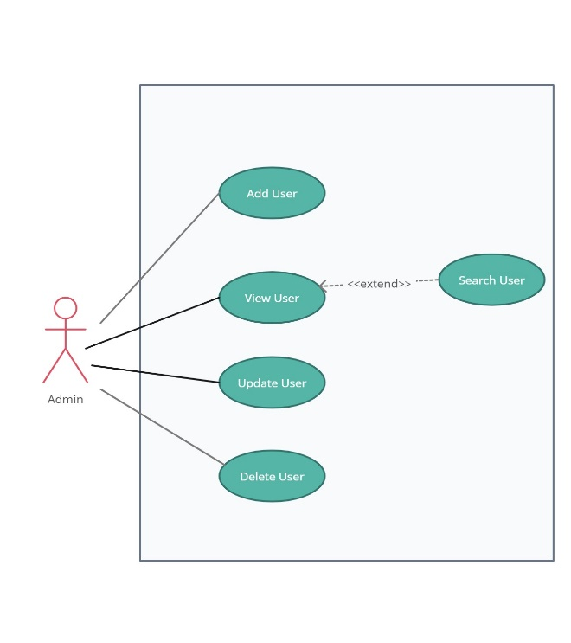

1. **Future scope and future enhancement:**

The future scope and potential enhancements for the User Management System project are extensive, reflecting the ongoing evolution of technology and the ever-changing needs of users and organizations. Here are some future scope and enhancement possibilities:

Different Services to be added in the future are as follows:

* Integration with Single Sign-On (SSO) Systems.
* Multi-factor Authentication (MFA).
* Advanced User Analytics.
* Personalization and Customization.
* Role-Based Access Control (RBAC).
* API Integration and Webhooks.
* Mobile App Support.
* Scalability and Performance Optimization.

**12. Conclusion**

In conclusion, the User Management System project offers a comprehensive solution for organizations to streamline user data management, enhance security, and improve operational efficiency. By centralizing user authentication, authorization, and administration, it empowers both administrators and users alike. With potential enhancements such as multi-factor authentication, personalized experiences, and API integrations, the system stands poised to evolve alongside technological advancements and changing user needs. Its future scope encompasses a wide range of possibilities, from advanced analytics to blockchain integration, ensuring its relevance and value in the ever-evolving digital landscape. Ultimately, the User Management System represents a cornerstone in fostering digital trust, promoting user empowerment, and driving innovation within the broader community.